Maven - Environment Setup( System settings)

- Verify Java Installation on your machine. (JDK1.5 or above)
- Set Java environment (JAVA_HOME, Path)
- Download Maven
http://www.eu.apache.org/dist/maven/maven-3/3.3.3/binaries/apache-maven-3.3.3-bin.zip
4. Extract to the directory you wish to install Maven 3.3.3
OS | Location (can be different based on your installation)
Windows | C:\Program Files\Apache Software Foundation\apache-maven-3.3.3
- Set Maven environment (MAVEN_HOME, Path)
Add MAVEN_HOME to environment variables. Append to system variable Path.
OS | Output
Windows | Set the environment variables using system properties.  MAVEN_HOME=C:\Program Files\Apache Software Foundation\apache-maven-3.3.3  Append the string ;%MAVEN_HOME%/bin to the end of the system variable, Path.

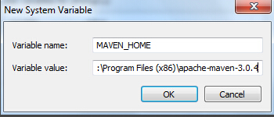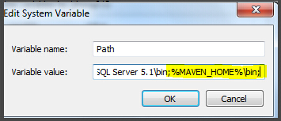
- Verify Maven installation ( cmd: mvn -version)
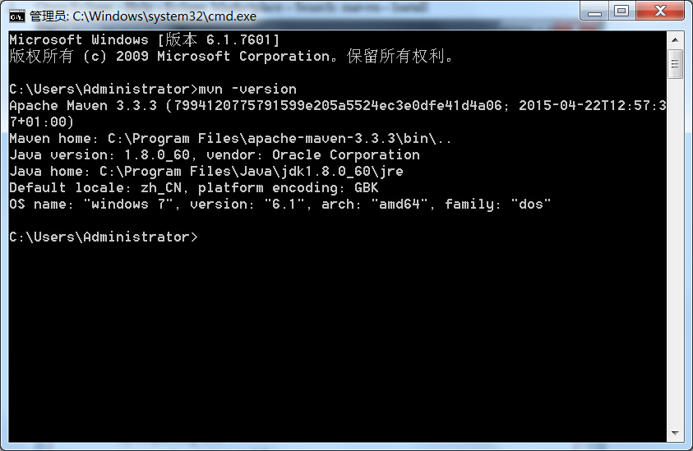

Maven - Environment Setup( Eclipse settings)

- Install Eclipse
- Open Eclipse - Help - Eclipse Marketplace - Search: maven - Install
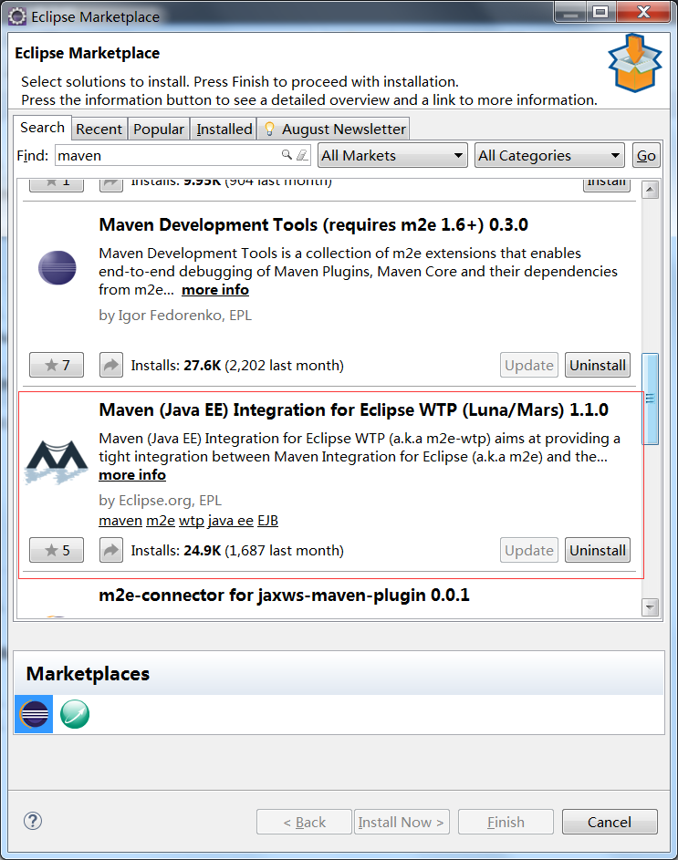

- Restart Eclipse
- Click Window - Preference - Maven - Installation - Add choose the folder maven installed.
- New Project - Other - Maven Project
- Add a .jar file as a maven dependency in pom.xml
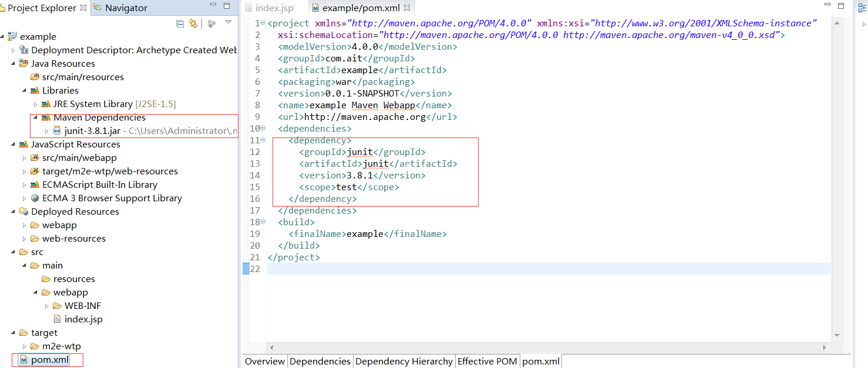

7. Right click on the project name - Build Path - Source, there are two missing folders we need to add manually.
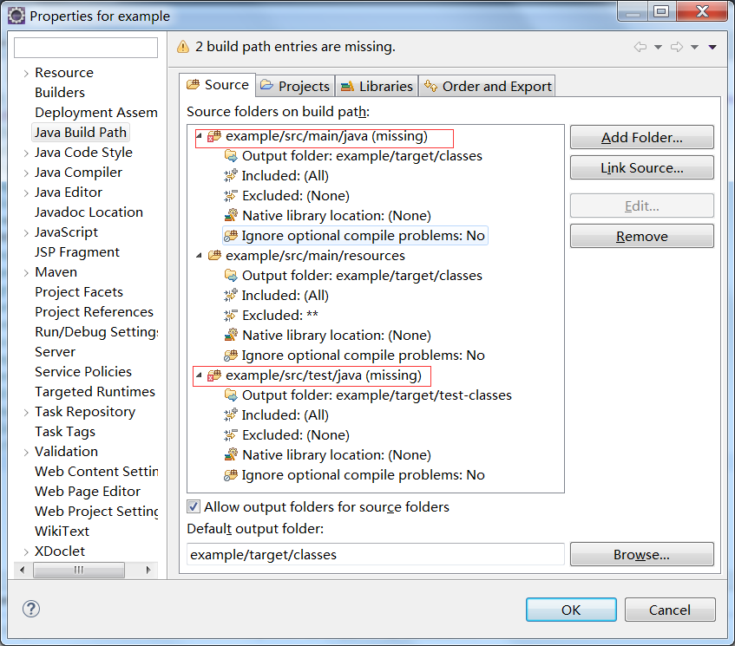
8. All settings done.

